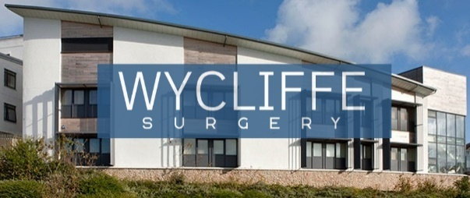
New Clinical Room!
We have been lucky enough to have another clinical room built and installed into part of the waiting area. This took a few weeks and we thank you for your patience whilst we were having these building works carried out. This will give us more space to hold clinics with our pharmacists, GPs, paramedics and nurses and we can’t wait to start making use of the room.

Telephone Callback Service
We have also recently installed a new callback service for our phone lines. During busy periods, you are given the option to request a call back instead of waiting in the queue for the phone to be answered. This will keep you space in the queue and it will automatically call you back once you reach the front of the queue and a member of the team is available.

Our Advanced Booking System
Some of you may already be aware of our new system with booking an appointment at the surgery but here is a bit of an explanation around the process of this.
Whilst we would love to offer an appointment for every patient when they asked for one, with a list size of over 11,500 patients, this just isn’t feasible currently. Therefore, we have introduced our advanced booking waiting list. Should you call up and request a routine appointment and there isn’t one available at the time, a member of the team will take as much information as possible regarding the appointment and document this on your record. You will then be allocated to a waiting list for that specific GP.
These waiting lists are checked daily and throughout the day by a member of the team as we have new appointments go live at 8am every day. Should an appointment be available that fits your request, we will be in touch to book this in. We aim to be in touch within two weeks to get this booked in.
We have had good feedback regarding this system and how it saves patients calling at 8am to find all the appointments are gone.

Welcome to the 1st Wycliffe Surgery Patient Newsletter!
As we approach the Summer, we want to share how excited we are to introduce our newsletter with you all. This has been created in conjunction with our Patient Participation Group and we look forward to sharing our updates with our patients over the coming months.

June ‘25
Newsletter
Wycliffe Surgery, Cattedown

Newsletter
Wycliffe Surgery, Cattedown

June ‘25
Frequently Asked Questions
We have noticed some questions are asked regularly over the phone or when you pop into reception so hopefully this will help with any queries that you might have!
Why is the ‘Contact Us Online’ not open 24 hours a day?
Whilst we appreciate that our contact us online service is an really useful way of contacting the surgery, it is not safe or manageable to have this open 24 hours a day. We have to close it after 6pm as these are not being triaged or monitored by a member of staff outside of working hours. If you have a medical concern after this time, we advise you to contact 111 or await our reopening at 8am.
Do I need a login to request my prescription?
No, there are various ways that you can contact us to let us know that you are needing your repeat prescription. This can be done via our prescribing email address: d-icb.wycliffesurgery.prescribing@nhs.net, via our website and through our contact us online on the home page.
Do I still need to request my prescription even though it is a ‘repeat’?
Yes. A repeat prescription is something that you have issued regularly without needing to speak to the doctor each time, it does not mean it is sent to the pharmacy automatically. You will still need to inform us of the medication request 7 days before you are due to run out in order for this to be sent to the pharmacy. Please see the previous questions for ways to do this.

Get in Touch!
If you wish to get in touch with the surgery to provide any feedback regarding the newsletter or anything else at the surgery, please use our feedback form on our website.

Thank you!
We want to thank you for taking the time to read our newsletter and appreciate any feedback that you might have and what things you might like to see in the next edition. If you wish to stay up to date with any other news at the surgery please use our website www.wycliffesurgery.co.uk or alternatively we regularly update our Facebook page.

Patient Participation Group
As mentioned previously, this newsletter was an idea from the Patient Participation Group (PPG). We have recently got this back up and running and after a successful first meeting, lots of ideas were generated amongst a very positive discussion as a group. We are always looking and happy to accept new members so if you are interested in joining our PPG, please let us know!

